PIZZA SALES ANALYSIS

SQL Queries

---Q1. Total Revenue

SELECT SUM(total_price) AS total_revenue

FROM pizza_sales

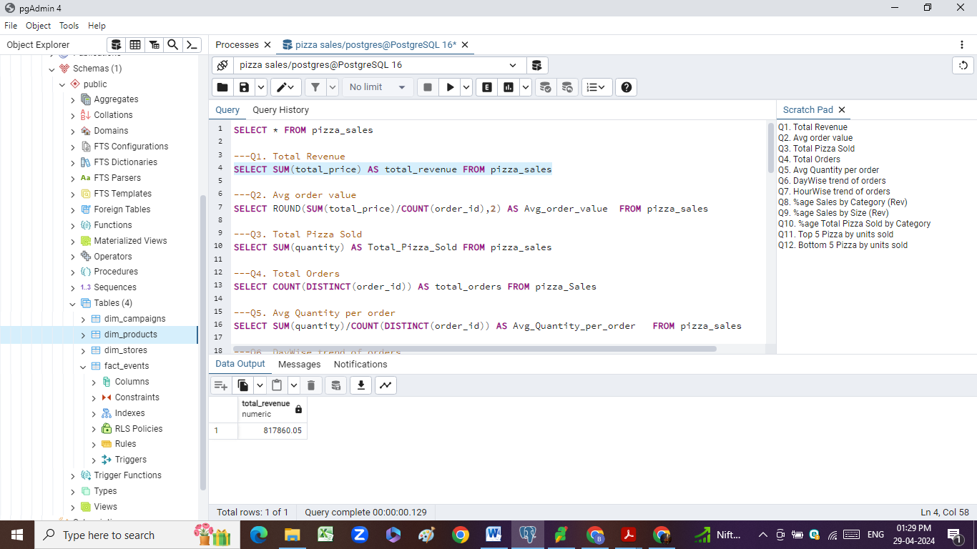

---Q2. Avg order value

SELECT ROUND(SUM(total_price)/COUNT(DISTINCT(order_id)),2) AS Avg_order_value FROM pizza_sales

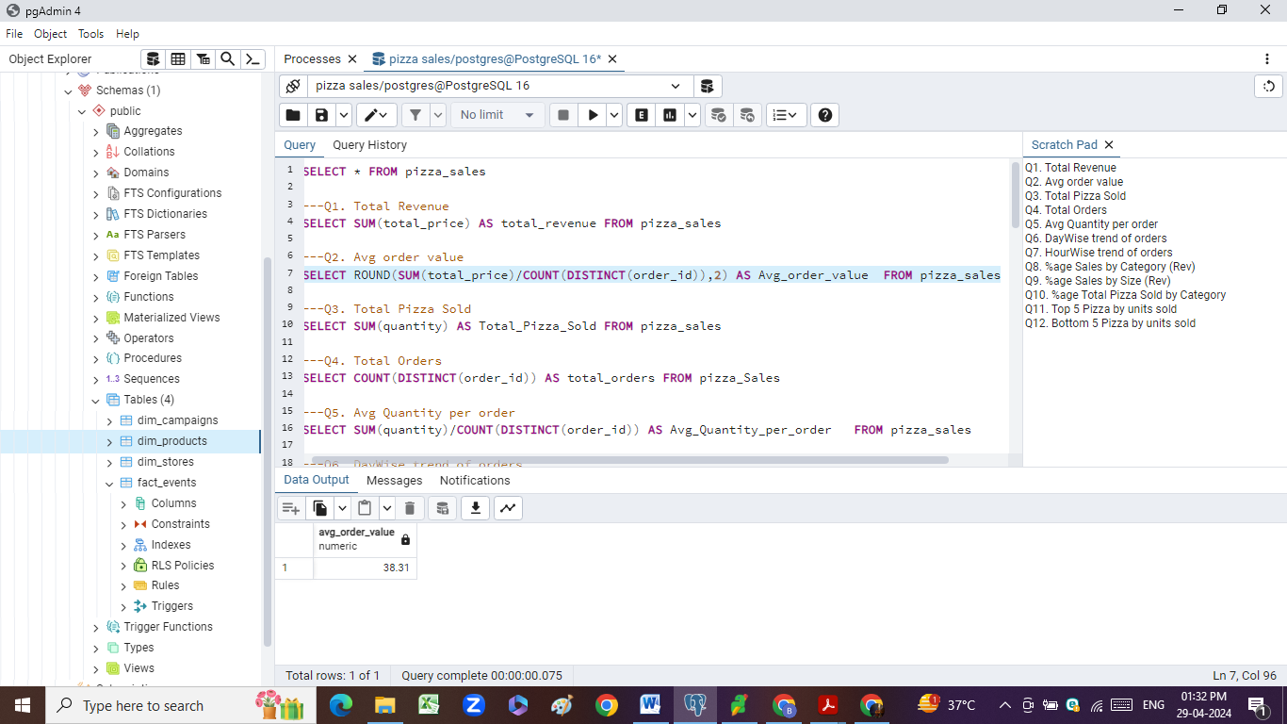

---Q3. Total Pizza Sold

SELECT SUM(quantity) AS Total_Pizza_Sold

FROM pizza_sales

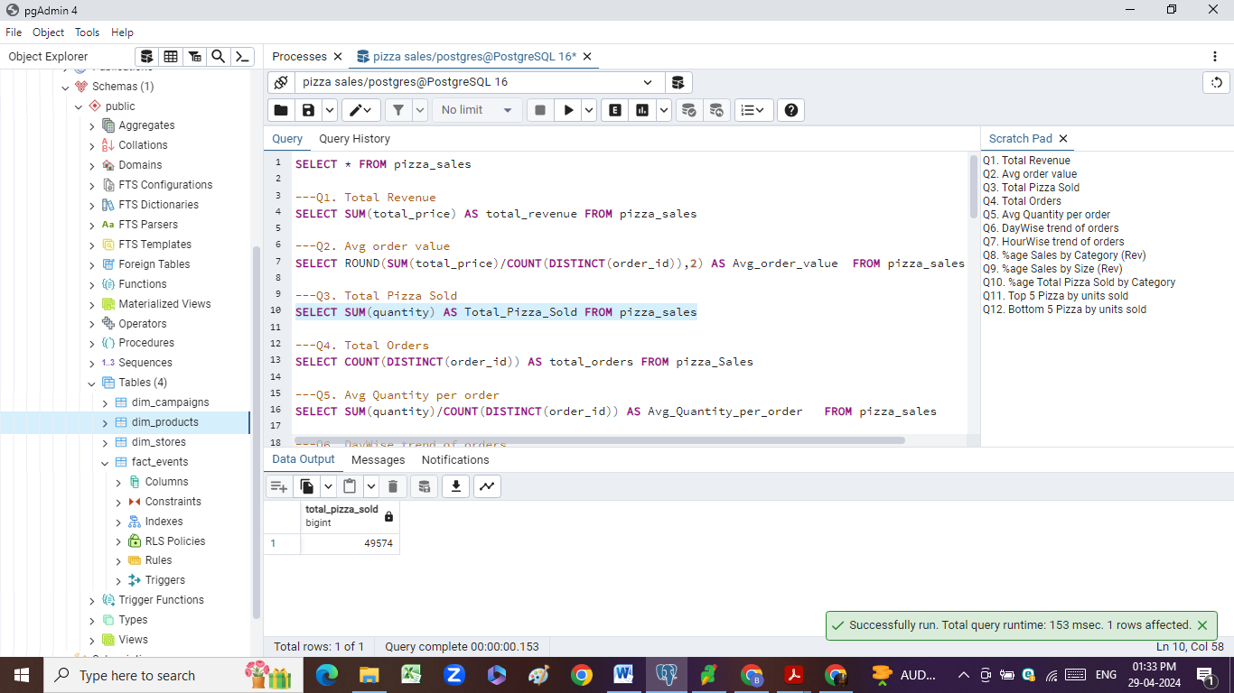

---Q4. Total Orders

SELECT COUNT(DISTINCT(order_id)) AS total_orders

FROM pizza_Sales

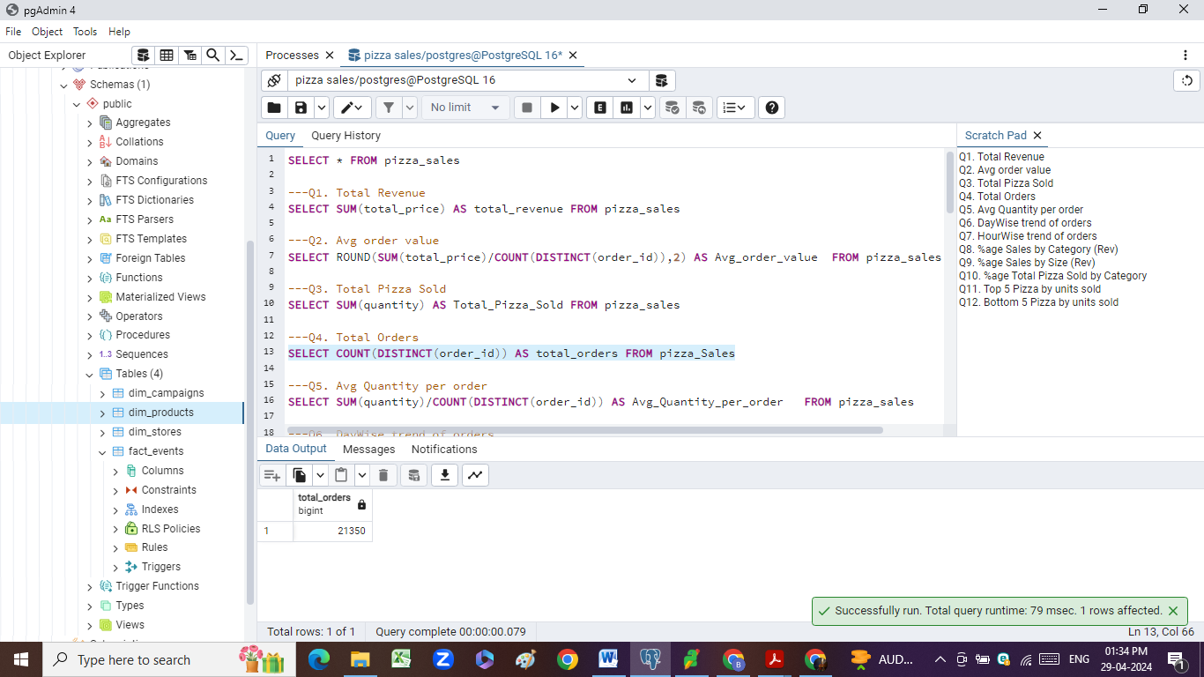

---Q5. Avg Quantity per order

SELECT SUM(quantity)/COUNT(DISTINCT(order_id)) AS Avg_Quantity_per_order

FROM pizza_sales

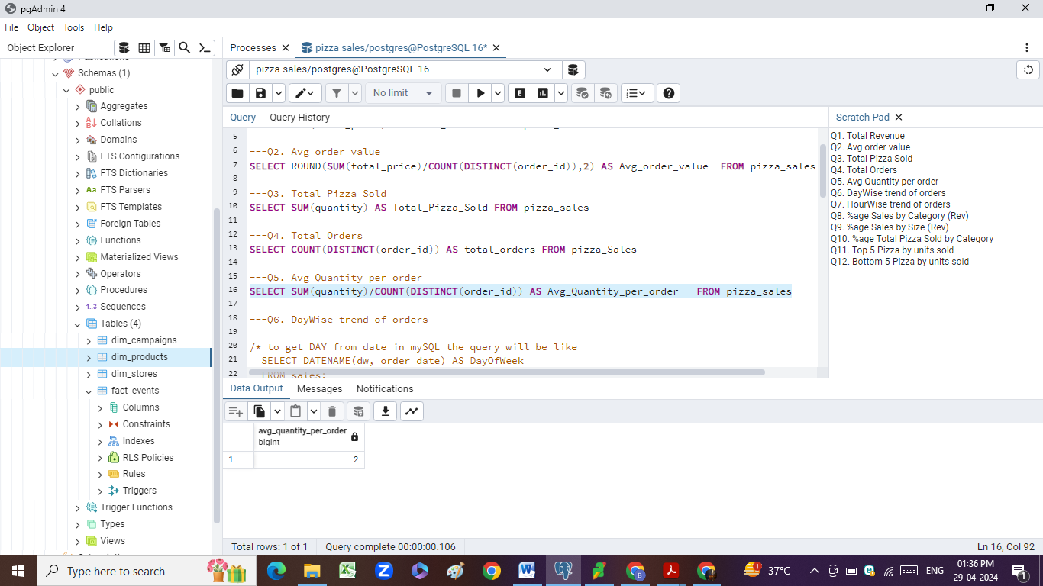

---Q6. DayWise trend of orders

*/* to get DAY from date in mySQL the query will be like*

*SELECT DATENAME(dw, order_date) AS DayOfWeek*

*FROM sales;*

*but in PostgreSQL same result query is Quite different*/*

SELECT TO_CHAR(order_date,'Day') AS order_day,

COUNT(DISTINCT(order_id)) AS total_orders

FROM pizza_sales

GROUP BY order_day

ORDER BY total_orders DESC

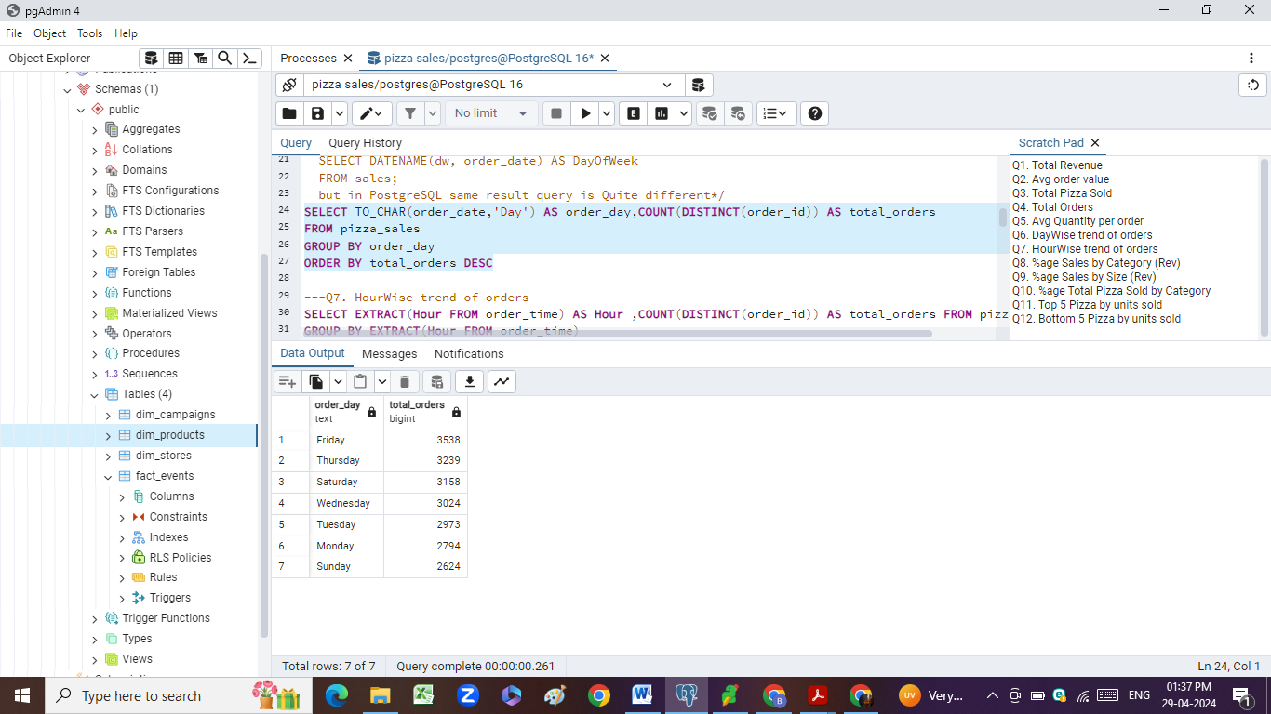

---Q7. HourWise trend of orders

SELECT EXTRACT(Hour FROM order_time) AS Hour ,

COUNT(DISTINCT(order_id)) AS total_orders

FROM pizza_sales

GROUP BY EXTRACT(Hour FROM order_time)

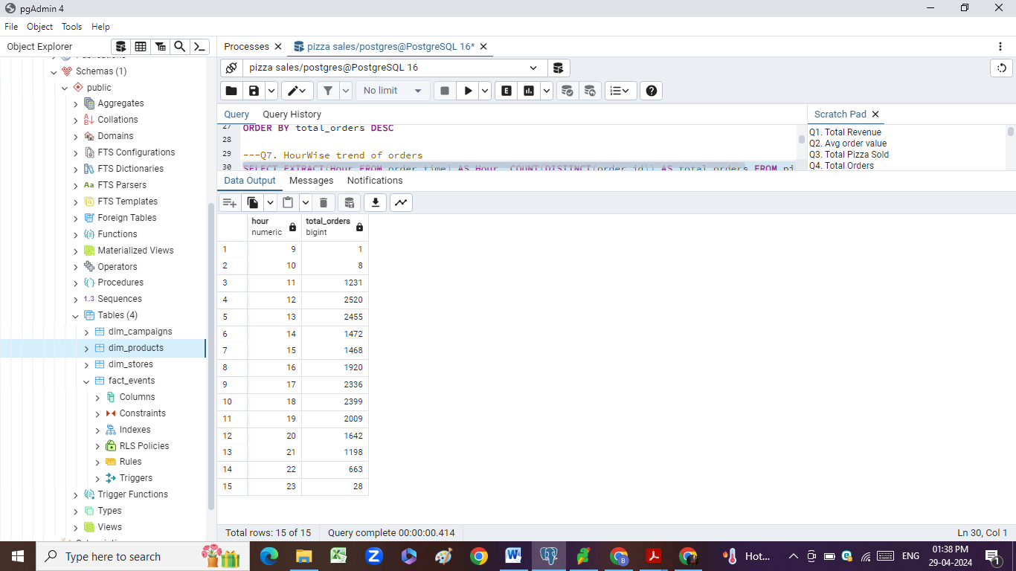

---Q8. %age Sales by Category (Rev)

/* Using Sub_query concept to get denominator Total revenue*/

SELECT pizza_category,

ROUND(SUM(total_price)*100 /

(SELECT SUM(total_price) FROM pizza_sales),2) AS Percentage_Revenue

FROM pizza_sales

GROUP BY pizza_category

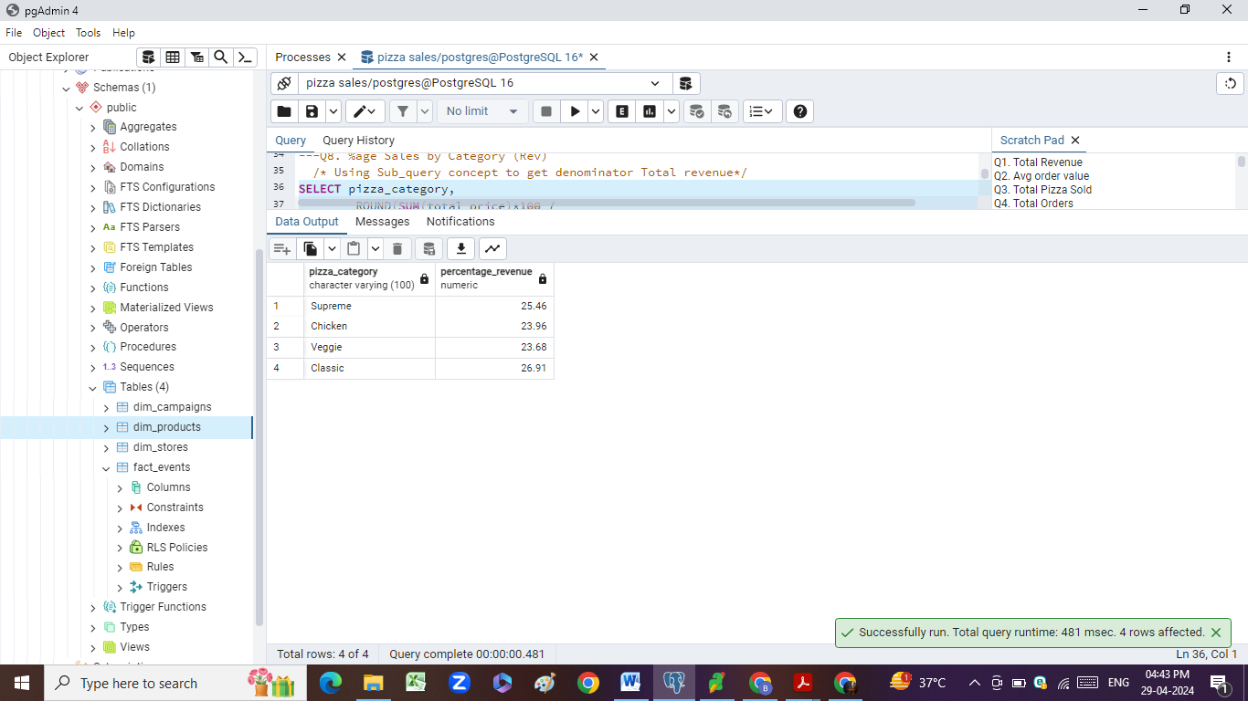

---Q9. %age Sales by Size (Rev)

SELECT pizza_size,

ROUND(SUM(total_price)*100 /

(SELECT SUM(total_price) FROM pizza_sales),2) AS Percentage_Revenue

FROM pizza_sales

GROUP BY pizza_size

ORDER BY Percentage_Revenue DESC

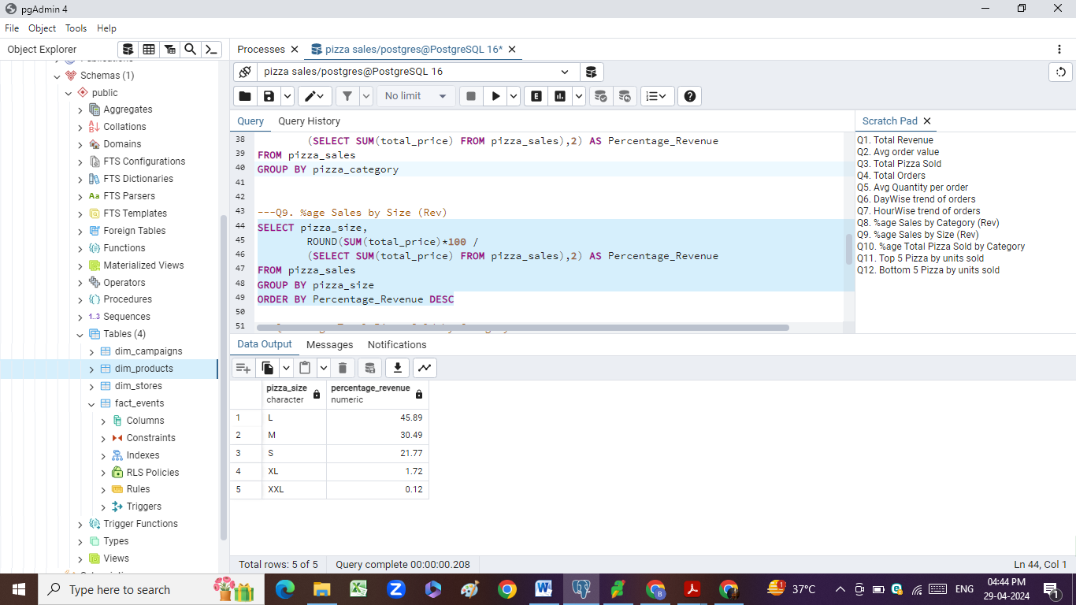

---Q10. %age Total Pizza Sold by Category

SELECT pizza_category,SUM(quantity)*100/

(SELECT SUM(quantity) FROM pizza_sales) AS PErcentage_Quantity

FROM pizza_sales

GROUP BY pizza_category

ORDER BY Percentage_Quantity DESC

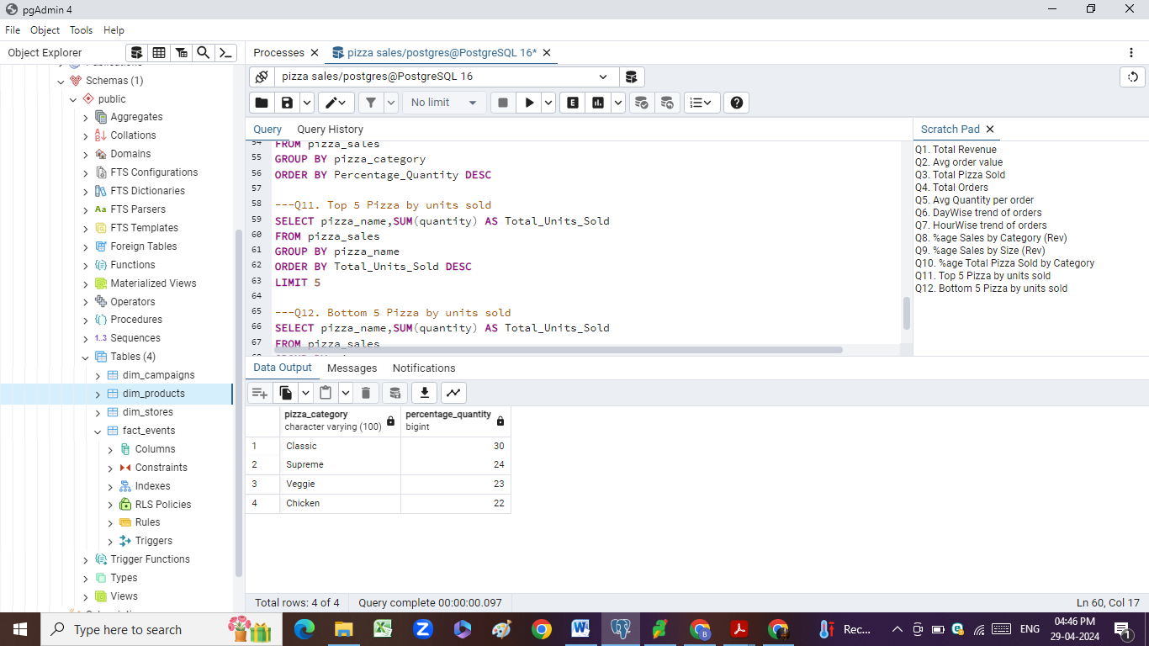

---Q11. Top 5 Pizza by units sold

SELECT pizza_name,SUM(quantity) AS Total_Units_Sold

FROM pizza_sales

GROUP BY pizza_name

ORDER BY Total_Units_Sold DESC

LIMIT 5

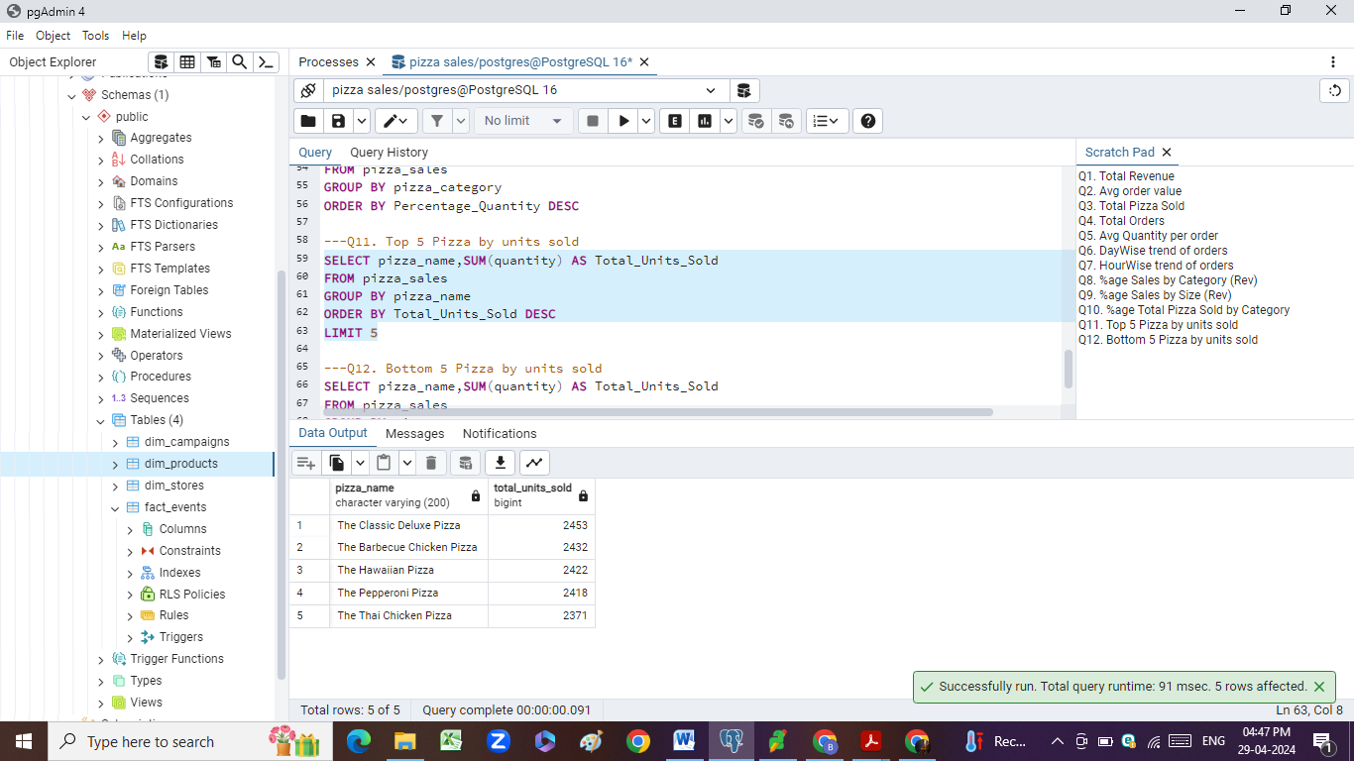

---Q12. Bottom 5 Pizza by units sold

SELECT pizza_name,SUM(quantity) AS Total_Units_Sold

FROM pizza_sales

GROUP BY pizza_name

ORDER BY Total_Units_Sold ASC

LIMIT 5

